**General Objective:**

Upon completion of this lab, the student will be able to calculate and graph instantaneous voltage and current waveforms in a series RC circuit (resistive capacitive). The student will construct the circuit, measure, and draw the instantaneous voltage waveforms. Additionally, the student will evaluate, analyze, and explain any discrepancies between the calculated and measured waveforms. The student will also consider test equipment characteristics and impacts on the circuits.

**References:**

1. Theory notes
2. First Year Text & Lab books
3. [1N60 datasheet](https://drive.google.com/file/d/1ObTFjvJngBM-Fpc0TDTIrtC2LTIK9ykf/view)

**Check-Off Sheet:**

1. [Check-Off Sheet](https://github.com/leistimo/RCET_ThirdSemester/blob/master/RCET2253/Lab%202/Lab2CheckoffSheet.pdf)

**Specific Objectives:**

Given the following Circuit (Fig 1):

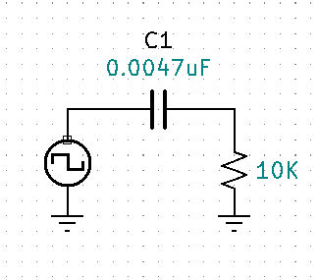

1. Calculations.
   1. With the square wave generator set to 0V to 8V and 1Khz. Calculate and document how many cycles it will take before the waveform signal will stabilize from the initial turn on of the generator. Draw each calculated waveform (VGEN, VR, and VC) in reference to the generator. Correctly label all waveforms from Times T0 to TSTABILIZED.
   2. Repeat step a with the generator adjusted to 100Khz. Correctly label all waveforms from Times T0 to TSTABILIZED.
   3. **Instructor Check**
2. Assemble, Measure and Document.
   1. Assemble circuit. For both 1Khz & 100Khz use the Heath/Schlumberger square wave generator, Capture and document the measured waveforms of VGEN, VR, and VC. Correctly label all waveforms from Times T0 to TSTABILIZED.
   2. **Instructor Check**
3. Analyze
   1. Compare, contrast, and document the calculated waveforms vs. measured waveforms of steps 1 & 2.
   2. **Instructor Check**
4. Differentiation.
   1. Define Differentiating.
   2. Choose a square wave frequency between 40Khz and 70Khz and design a differentiating circuit using a 0.0047uF capacitor. Document the design process and final circuit.
   3. Draw each calculated waveform (VGEN, VR, and VC) in reference to the generator.
   4. Assemble the circuit, use the Heath/Schlumberger square wave generator, measure the differentiated waveforms.
   5. Capture and document the measured waveforms of VGEN, VR, and VC. Correctly label all waveforms. Identify and document any discrepancies between the predicted and measured waveform.
   6. **VERIFY WITH YOUR INSTRUCTOR (4c, 4d, 4e, explain “what is Differentiation?”)**
5. Integration.
   1. Define Integration.
   2. Choose a square wave frequency between 10Khz and 30Khz and design an integration circuit using a 0.0047uF capacitor. Document the design process and final circuit.
   3. Draw each calculated waveform (VGEN, VR, and VC) in reference to the generator.
   4. Assemble the circuit, using the Heath/Schlumberger square wave generator, measure the integrated waveform.
   5. Capture and document the measured waveforms of VGEN, VR, and VC. Correctly label all waveforms. Identify and document any discrepancies between the predicted and measured waveform.
   6. **VERIFY WITH YOUR INSTRUCTOR (5c, 5d, 5e, explain “what is Integration?”)**

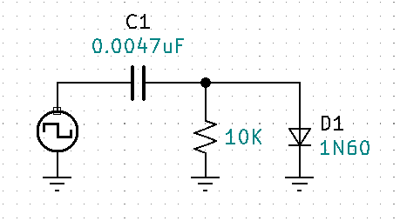Given the following Circuit (Fig 2):

1. Calculations
   1. With the square wave generator set at 0 to 8V & 1Khz, calculate and document the predicted waveforms VGEN, VC, VR, and VD1.
   2. Repeat step a with the generator adjusted to 100Khz. Correctly label all waveforms.
2. Assemble, Measure, and Document
   1. Assemble circuit. For both 1Khz & 100Khz use the Heath/Schlumberger square wave generator. Document measured waveforms of VGEN, VC, VR, and VD1. Correctly label all waveforms.
   2. With the generator set to square wave, 0 to 8V, and 1Khz. Compare, contrast, and document the calculated waveforms vs. measured waveforms.
   3. Repeat step b at 100Khz.
3. Analyze
   1. Compare, contrast, and document the calculated waveforms vs. measured waveforms of steps 6 & 7.
   2. **VERIFY WITH YOUR INSTRUCTOR (6, 7, & 8)**

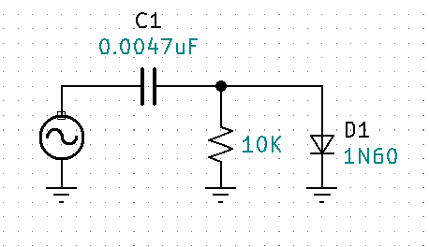Given the following Circuit (Fig3):

1. Calculations
   1. With the sine wave the generator is set to 8vp and 1Khz. Calculate and document the predicted waveforms VGEN, VC, VR, and VD1.
   2. Repeat step a with the generator adjusted to 100Khz. Correctly label all waveforms.
2. Assemble, Measure, and Document
   1. Assemble circuit. For both 1Khz & 100Khz use the Heath/Schlumberger square wave generator. Document measured waveforms of VGEN, VC, VR, and VD1. Correctly label all waveforms.
   2. With the generator set to sine wave, 8vp, and 1Khz. Compare, contrast, and document the calculated waveforms vs. measured waveforms.
   3. Repeat step b at 100Khz.
3. Analyze
   1. Compare, contrast, and document the calculated waveforms vs. measured waveforms of steps 9 & 10.
   2. **VERIFY WITH YOUR INSTRUCTOR (9, 10, & 11)**
4. Complete Conclusion and submit completed Check-Off sheet and Lab writeup in Moodle.